February 21st, 2023

Greetings from your locally led conservation district! The Crook County Natural Resource District (CCNRD) received a small amount of grant funding to help landowners in the Miller and Lytle Creek areas to reduce threats from catastrophic wildfires. Treatment examples include defensible space, fuel breaks, and fuel treatments. Defensible space projects help protect structures; fuel breaks help stop wildfires; and fuel treatments are similar to an aggressive thinning project to reduce fuel for wildfires.

The CCNRD has limited funding available and will prioritize applications submitted prior to April 10th of 2023. If you are interested in applying, please fill out an application which can be found at www.ccnrd.org or pick one up at the USDA Service Center (117 South 21st Street, Sundance).

The CCNRD is primarily a grant-funded agency, and we currently assist landowners with a variety of natural resource-based projects, including water quality, forest health, wildlife habitat, soil health, and range management improvement projects. Additionally, we host annual electronic recycling events in the fall and our tree sale program is being offered now through April 12th, 2023. More information about our programs can be found on our website, www.ccnrd.org, including the application for this hazardous fuels reduction program. Please reach out with any questions!
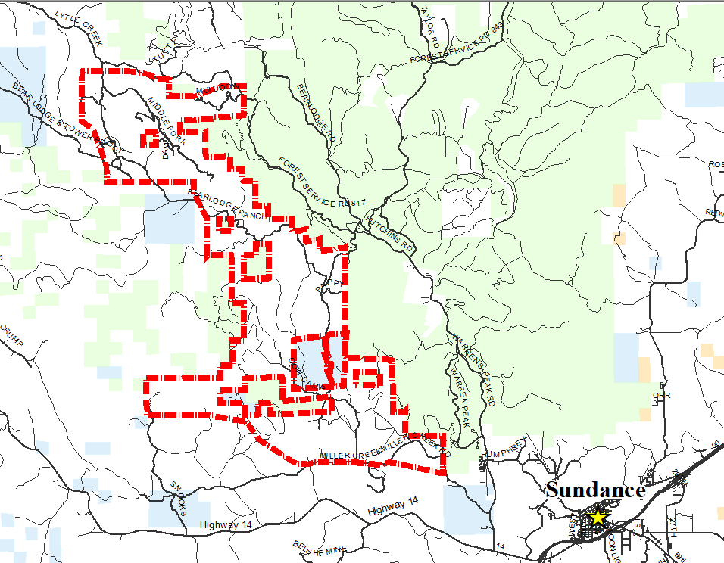
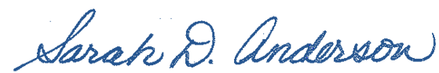
Kind regards,

Sarah Anderson
Miller Creek
Hazardous Fuels
Reduction Project

